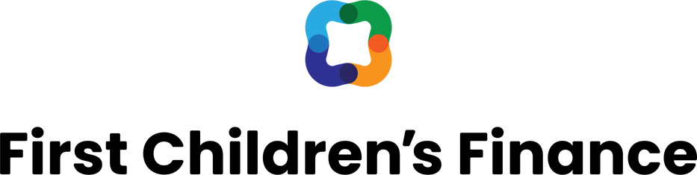
ACT 76

FAMILY COMMUNICATION
Points to help Vermont families with young children
understand Act 76, state funding, and child care tuition assistance.

What are the changes for families?
The 2023 Child Care Bill, Act 76, includes a long-term annual investment of $125 million into Vermont’s child care sector. It is intended to make early childhood education more affordable and accessible for families, stabilize the early childhood education workforce, and support Vermont’s economy.
Vermont has a program to help families cover the cost of child care tuition. It’s called CCFAP, for Child Care Financial Assistance Program. The program is overseen by the Department for Children and Families’ Child Development Division. Here is the link: dcf.vermont.gov/benefits/ccfap
By the end of 2024, most Vermont families will be eligible for child care tuition assistance. CCFAP eligibility expands in April and again in October, based on a percentage of federal poverty levels. Ultimately, eligibility will expand to families earning up to 575% of the federal poverty level: for example, up to $179,400 for a household of four. That represents approximately 7,000 additional Vermont families with young children.
Newly eligible families will need to apply for CCFAP. After a family enrolls in CCFAP, the state directly reimburses the child care programs their children attend. As a result, the family’s out-of-pocket tuition bills are lower.

How does it work?
Vermont needs more excellent child care. Changes must come in a specific order for this to happen.
The state reimburses child care programs directly: this is unchanged. Act 76 increased tuition reimbursement rates to child care programs in July 2023 and again in January 2024. The increased state funding is to pay programs closer to the true cost of quality care and to remove the excessive cost burden on families.
Increasing state reimbursement rates first–before more families become eligible for assistance–helps child care programs stabilize their finances and expand. That creates more child care availability for when more families become eligible for tuition assistance.
At the same time, Act 76 limits the amount a program can increase its private pay tuition rate.
This limit will be adjusted each year, based on a measure of inflation. For FY24 (the current year), a child care program in Vermont may increase their tuition rates no more than 7.2% over the rate they charged in FY23.
Act 76 also limits the types of fees that programs can charge to families that receive tuition assistance. However, it does not eliminate all fees or set limits to the cost of allowed fees.
There will be a new list of “family share” amounts in early 2024 based on the updated Federal Poverty Guidelines. We expect more guidance on the changes to CCFAP eligibility and a revised schedule of “family share” amounts early in 2024.

Do you need more information about the changes?
Please reach out to First Children’s Finance or your local Community Child Care Support Agency.

January 2024

